****ITMS 528: Database Security and Compliance Implementation

**Project Management Plan**

Department of Information Technology and Management

**November 2023**

**Group Project Members:**

Ishan Prabhune (A20538828)

Pratik Darade (A20536376)

Harshal Sawant (A20538827)

Raj Dedhia (A20551543)

Aniket Singh (A20546525)

**Revision History**

Note: The revision history cycle begins once changes or enhancements are requested after the document has been baselined

**Artifact Rationale**

The Project Management Plan (PMP), according to the Guide to the Project Management Body of Knowledge (PMBOK®), is a formal, approved document used to guide both project execution and project control. The primary uses of the PMP are to document planning assumptions and decisions, facilitate communication among stakeholders, and document approved scope, cost, and schedule baselines. By showing the major products, milestones, activities and resources required on the project, it is also a statement of how and when a project's objectives are to be achieved.

The project manager creates the PMP following input from the project team and key stakeholders. The plan should be agreed on and approved by at least the project team and its key stakeholders.

The PMP is mandatory for all projects. While it is a project-level document, it should be updated as necessary, including for each increment

**Table of Contents**

[**1.**](file:///C:\Users\prati\Desktop\PMP.docx#_heading=h.1fob9te) **Introduction 1**

[**1.1.**](file:///C:\Users\prati\Desktop\PMP.docx#_heading=h.3znysh7) **Project Overview 1**

[**1.2.**](file:///C:\Users\prati\Desktop\PMP.docx#_heading=h.2et92p0) **Scope Statements 1**

[**1.3.**](file:///C:\Users\prati\Desktop\PMP.docx#_heading=h.tyjcwt) **Goals and Objectives 1**

[**1.4.**](file:///C:\Users\prati\Desktop\PMP.docx#_heading=h.3dy6vkm) **Stakeholders and Key Personnel 1**

[**2.**](file:///C:\Users\prati\Desktop\PMP.docx#_heading=h.1t3h5sf) **Project Organization 1**

[**3.**](file:///C:\Users\prati\Desktop\PMP.docx#_heading=h.4d34og8) **Acquisition Process 1**

[**4.**](file:///C:\Users\prati\Desktop\PMP.docx#_heading=h.2s8eyo1) **Monitoring and Control Mechanisms 1**

[**5.**](file:///C:\Users\prati\Desktop\PMP.docx#_heading=h.17dp8vu) **Systems Security Plans and Requirements 1**

[**6.**](file:///C:\Users\prati\Desktop\PMP.docx#_heading=h.3rdcrjn) **Work Breakdown Structure (WBS) and Schedule 2**

[**7.**](file:///C:\Users\prati\Desktop\PMP.docx#_heading=h.26in1rg) **Project Success Criteria 2**

[**8.**](file:///C:\Users\prati\Desktop\PMP.docx#_heading=h.lnxbz9) **Communication Management Plan 2**

[**9.**](file:///C:\Users\prati\Desktop\PMP.docx#_heading=h.35nkun2) **Risk Management Plan 2**

[**10.**](file:///C:\Users\prati\Desktop\PMP.docx#_heading=h.1ksv4uv) **Software Configuration Management (SCM) Plan 2**

[**11.**](file:///C:\Users\prati\Desktop\PMP.docx#_heading=h.44sinio) **Training Plan 2**

[**12.**](file:///C:\Users\prati\Desktop\PMP.docx#_heading=h.2jxsxqh) **Quality Assurance Plan 2**

[**13.**](file:///C:\Users\prati\Desktop\PMP.docx#_heading=h.z337ya) **Project Measurement Plan 2**

[**13.1.**](file:///C:\Users\prati\Desktop\PMP.docx#_heading=h.3j2qqm3) **Description 3**

[**13.2.**](file:///C:\Users\prati\Desktop\PMP.docx#_heading=h.1y810tw) **Performance Measurements 3**

[**14.**](file:///C:\Users\prati\Desktop\PMP.docx#_heading=h.4i7ojhp) **Reference Materials 5**

[**Approval Signatures 6**](file:///C:\Users\prati\Desktop\PMP.docx#_heading=h.2xcytpi)

**[15.](file:///C:\\Users\\prati\\Desktop\\PMP.docx" \l "_heading=h.1ci93xb)****Project Plan Approval 6**

**16. Appendix 7**

**1. Introduction**

This PMP describes the project management processes that ITMS 528 will follow during execution of the ITMS 528 Group project. Project management processes shall be aligned with the plans and procedures of the Project Management Accountability System MASP Guide New processes shall be defined for all management areas not covered by the PMAS Guide. This Project Management Plan shall lay down the management practices for the duration of the project. To reflect changes, this document will be updated according to these practices.

* 1. **Project Overview**

This project will deliver a database with implementation of different controls using the NIST Risk Management Framework into said database. A database with over 1000 entries and more than 5 users will have a minimum of 7 tables. The creation of a database, as well as the application of control schemes, will be performed using MySQL and SQL Workbench.

* 1. **Scope Statements**

Appendix A, "Project Charter," can be found here.

* 1. **Goals and Objectives**

For more information, see Appendix A to the Project Charter.

* 1. **Stakeholders and Key Personnel**

For more information, see Appendix A to the Project Charter.

**2. Project Organization**

For more information, see Appendix A to the Project Charter.

**3. Acquisition Process**

This project does not have a procurement procedure in place due to the fact that there are no outside contractors or companies involved and necessary for completion of this project. Without needing external contractors to do so, all the tools and software used in this project shall be open source or free of charge.

**4. Monitoring and Control Mechanisms**

The project shall comply with the standard risk management, requirement traceability and operating readiness monitoring and control processes established in ProPath. Various communication methods, including virtual meetings and discussion onWhatsApp, have been used to monitor the team's progress. In order to ensure that the timetable displayed the required time for each of the projects components, the project manager was in charge of communicating progress with regard to different tasks on the Project Schedule and WhatsApp Group Chat. The WhatsApp platform communicated all required updates and changes to the deadline. In order to guarantee that the members of the group are aligned and on course with completion of project deliverables, meetings have also been planned and convened.

**5. System Security Plans and Requirements**

In the planning phase of projects, system security plans and requirements will be drawn up.

|  |  |  |
| --- | --- | --- |
| **Resource** | **Security Plan** | **Status** |
| File Storage | Team Google Drive has all project files in it, and only members of the team can access them. | Applied |
| WhatsApp | The WhatsApp group chat was used for primary communications. The WhatsApp group chat requires a direct invitation to join, this was sent to all team members. | Applied |

**6. Work Breakdown Structure and Schedule**

The breakdown structure and schedule for work are set out in Appendix B, Work Breakdown Structure and Schedule.

**7. Project Success Criteria**

|  |  |  |
| --- | --- | --- |
| **Category** | **Goal** | **Success Criteria** |
|  | Group Formation | 5 members only |
|  | Group members access the tasks. | Tasks are assigned by project manager and group members are controlled based on individual experience and preference. |
|  | Project Schedule is established and enforced. | The Project Manager shall, where appropriate, create and maintain a project schedule. |
| **Project Planning and**  **Management** | Complete the Risk Management Log | The Risk Management Log shall be used for identification, documentation, and monitoring of project risks. |
|  | Complete the EVM Workbook. | The correct calculations and cost estimates for the members of the group are completed in the EMV workbook. |
|  | Complete the Project Management Plan. | The project management plan has been completed in the most precise way possible. |
|  | Monitor the risks and conflicts in the project schedule. | The WhatsApp group chat is used to discuss disputes among members of the group. |
|  | Select the project storage | The selection and the use of GitHub's Repository for storing project files. |
| **Database Creation** | Select database tables to import and use them. | The choice of what database set to be used by the project. |
|  | Create user accounts | The creation and maintenance of user accounts for databases. |
| **Control Implementation** | Control(s) implementation | The implementation of the required project control procedures with respect to databases that have been selected before. |
| Testing and debugging | The controls have been tested and analyzed as necessary after they were put in place. |
| Final checkthrough | In order to ensure that all project requirements are met, a final walkthrough will be carried out. |

**8. Communication Management Plan**

WhatsApp is the primary means of communication for this project. In-class group meetings and virtual meetings sessions are also possible.

**8.1 WhatsApp**

The group chat on whatsapp took care of all communications between the team and its members. Communication in a WhatsApp Group chat may include, but is not limited to, written messages, images, and files.

**8.2 Team Meetings**

The team also had an additional NUM meeting on the fly in addition to their meetings during class.

|  |  |
| --- | --- |
| **Meeting Date** | **Location** |
| November 1, 2023 | Google Meet |
| November 10, 2021 | Google Meet |
| November 20, 2021 | Google Meet |

**9. Risk Management Plan**

Risks for this project will be identified, documented, and tracked using a Risk Management Log. A response strategy will be created for every risk identified, with the Project Manager leading the efforts to prevent the risk and/or mitigate its effects.

**10. Software Configuration Management Plan**

|  |  |  |
| --- | --- | --- |
| **Category** | **Software/Modules** | **Version** |
| **Project Planning and**  **Management** | Project Libre | 1.9.3 |
|  | MySQL | 8.0.35 |
| **Database Creation and** | MySQL Workbench | 8.0.34 |
|  | Ubuntu | 22.04 |

**11. Training Plan**

The Project Manager shall decide on training for all members of the group. The following requirements shall be known to all members of the group:

* MySQL
* MySQL Workbench
* Ubuntu
* GitHub

Further outside agencies and programs which may be of use are also capable of providing training if necessary. The fact that the members of the group have been assigned tasks based on their existing expertise is not expected to result in any major training.

**12. Quality Assurance Plan**

**12.1 Introduction**

The project management team shall be responsible for monitoring and managing the project as well as of its members in Project Groups. For what Project Management Team will be regulating, the quality assurance plan itself is used as a guide. The various tasks, qualifications, and training necessary, the objectives of the group in order to achieve those objectives as well as the standards that it will have to meet on verification and validation shall be laid down in the Quality Assurance Plan. of the project.

**12.2** **Defining Rules**

Project Manager: The Project Manager shall be responsible for managing the Team and organization of communications between Members of the Working Party, who document the project.

Database Administrator The administrator is someone who's going to be able to access everything with regard to the database and server side.

Database Manager: It will provide complete access, but this won't be identical to the administrator.

Database Designer: If necessary, the Designer will be assigned a role to create, edit and make users. They're the ones that are going to build this database.

**12.3 Roles Qualification**

Prior experience and preference have been used to determine the qualifications of each role. Instructions concerning the project have been sent to all members of the Group, setting out what they are expected to do and their responsibilities.

**12.4 Objectives and Standards**

The ITMS 528 group will create and develop the database based off of the instructions that they were given. The ITMS 528 group will also follow standards set by the group members prior to starting on the project itself.

**12.5 Verification**

All group activities are reviewed prior to final submission with a view to ensuring that all Group Members have fulfilled their respective tasks correctly. A final walkthrough and double check is performed by the Project Director to ensure that all necessary documentation and tasks have been completed. Furthermore, prior to the ultimate submission and walkthrough, all of the group work shall be tested and audited by its members.

**13. Project Management Plan**

**13.1 Description**

Measurement targets derived from project requirements and objectives shall be set out in the Project Measurement Plan. We measured the successful creation of at least seven tables with 1000 records in terms of metrics related to database creation. For the metrics in the control implementation, we measured the successful implementation and testing of the required controls. Test of functionality and the ability to produce accurate results was used to measure these metrics.

**13.2 Performance Measurements**

**ITMS 528 Group Project Performance Measurements**

|  |  |  |  |
| --- | --- | --- | --- |
| **No.** | **Measurement Name** | **Measurement Objective** | **Metric** |
| 1. | Implementing controls | The required controls are carried out and function as intended. | Project Success Criteria |
| 2. | Testing controls | Successfully, the required controls have been put in place and comply with project requirements. | Project Success Criteria |
| 3. | Testing database | The database tables have been successfully created and meet the project requirements | Project Success Criteria |
| 4. | Data Collection | The information necessary shall be generated and summarized in the audit reports. | Project Success Criteria |
| 5. | Documentation | The project documents document all necessary resources and materials for the project. | Project Success Criteria |

**14. Reference Materials**

Group Communication/Organization

● Project Libre

● WhatsApp

Database Creation / Control Implementation

● MySQL

● MySQL Workbench

● Ubuntu

**Approval Signatures**

PAO has additional approver language:

**15. Project Plan Approval**

The following signatures shall indicate that the person signing them is:

● The plan for the project has been reviewed.

● He formally raised the relevant issues with the Prime Minister.

● Indicate that their expectations and conditions necessary to implement this project have been accurately reflected in the Project Plan.

● They are committed to the provision of the necessary resources.

● Don't know about the unconcealed conditions preventing this project from being successful.

1. **Project Charter**

|  |  |
| --- | --- |
|  | Project Information |
| Project Name | ITMS 528 Database Security Project |
| Project Number | 1 |
| Project Manager | Pratik Darade |

|  |
| --- |
| Project Overview |
| This project will deliver a database with implementation of different controls using the NIST Risk Management Framework into said database. A minimum of 7 tables with more than 1000 records and 5 users shall be included in the database. The creation of the database, as well as the implementation of the controls, will be done using MySQL and MySQL Workbench. |
| Project Deliverables |
| * Choose between seven tables with a minimum of 1000 entries. * Set up a minimum of 5 users. * Continue to perform required controls in the databases. * All documentation on project management is completed. * Develop a presentation with our project processes, findings and ultimate deliverables. |
| Project Goals and Objectives |
| 1. Creation of more than 7 tables with a minimum of 1000 entries per table 2. Ensuring the implementation of the necessary controls 3. Testing and debugging of the controls that have been implemented. 4. Presentation of project outcomes |
| Scope Statement |
| A minimum of seven tables with 1000 entries in the database are required to deliver the final project deliverables. The tables will have the required implenations, and they'll be created in MySQL Workbench. |

Project Schedule

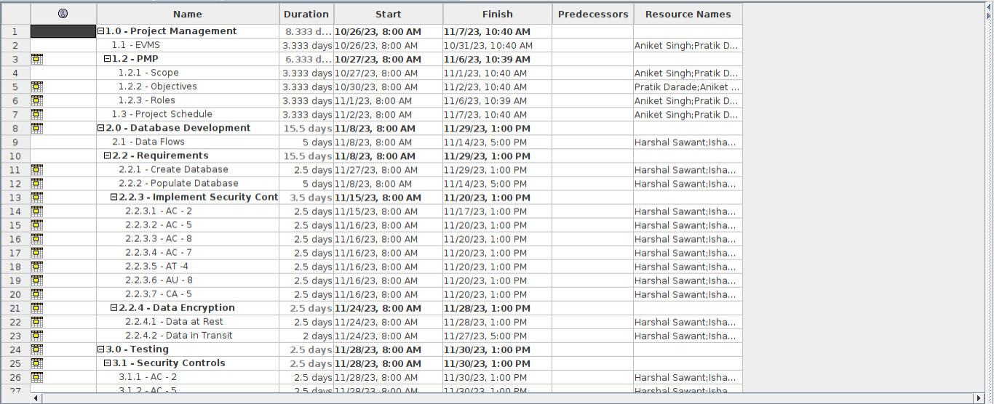

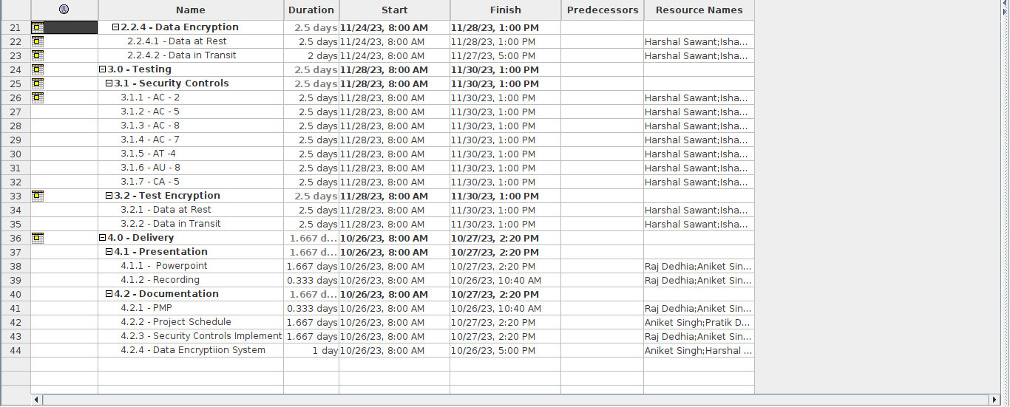

|  |
| --- |
| Risks |
| *Assumptions* |
| 1. The group must have the necessary number of members to complete this project. 2. To complete this project, there is a need for an appropriate number of members in the group. 3. Virtual communication will have a very important role to play in each member's personal schedules. |
| *Constraints* |
| 1. It is not likely that the deadlines for completion of the project would be enough, as members of the group will have to split their time between theoretical work and more practical tasks. 2. Some deadlines and meetings may come to a stop during the holiday period, which can make it hard for some team members to complete their tasks. |

|  |  |
| --- | --- |
|  | Dependencies |
| *Task* | *Depends On* |
| Database Creation | Selection of not less than 7 tables with 1,000 entries. |
| Controls Implementation | To implement the required checks on database tables. |
| Testing and debugging | The completion of database creation and control implementation is required. |
| PM Document Completion | Complete documentation of the PMP, EVM Workbook and Risk Management Log is required. |

|  |  |
| --- | --- |
|  | Stakeholders and Key Personnel |
| *Stakeholders/Key Personnel* | *Responsibilities* |
| Project Manager | Responsible for day to day management of project, and must be able to manage the scope, timetable, financing, risk control, quality and resources. |
| Database Designer | Develop and build a database needed for this project by communicating with the Project Manager |
| Database Manager | If you want to manage what types of access users have, talk to the project manager. |
| Database Admin | In order to complete the administrative tasks, communicate with the project manager |

|  |  |  |
| --- | --- | --- |
|  | Project Organization |  |
| *Team Member* | *Title* | *Department* |
| Pratik Darade | Project Manager | Management |
| Ishan Prabhune | Database Admin | Administration |
| Harshal Sawant | Database Manager | Management |
| Raj Dedhia | Database Designer | Design |
| Aniket Singh | Database Designer | Design |